**Medical Graph assignment**

**Please read the following instructions carefully to create the Nodes and Relationships**

**Nodes**

Create a graph database that has 20 patients with 3 properties – 10 should be females and 10 males

* Name
* Age
* Sex

Create 10 disease conditions with property “Type” for the following

* Heart disease
* Kidney disease
* Diabetes
* Breast Cancer
* Lung Cancer
* Blood Pressure
* Obesity
* Pancreatic Cancer
* Crohns Disease
* Prostrate Cancer

Create 4 doctors with 4 properties two should be family doctors and two should be specialists

* Name
* Age
* Sex
* Speciality “Family Doctor”,” Specialist”

**Relationships**

Create a relationship “Has_Disease” and associate 10 patients(the first 5 men and the first 5 women) with “Kidney disease” , “Heart Disease” and “Blood Pressure” your next 3 female(patsy,Cheyrl,Pamela) patients should have the relationship “Has_Disease” associated with “Breast Cancer” add 3 male patients (parick,john,Michael) with the relationship to ” Prostrate Cancer” add Andrew having “Obesity”,”Diabetes”,”Chrons”- Henry has “Lung cancer” ,”Pancreatic” and Betty has “Lung Cancer” and “Diabetes” Theresa has “Crohns” and Claudette Has “Diabetes”

Create the relationship “Treats_Disease” associate the two specialists with “Breast Cancer”,”Pancreatic Cancer”,”Lung Cancer”,”Prostrate Cancer” then associate the two Family Doctors with “Heart Disease”,”Kidney Disease”,”Diabetes”,”Blood Pressure”,”Obesity”,”Crohns Disease”

|  |  |  |
| --- | --- | --- |
| Name: "Orren graph" | Age: 25 | Sex: "M" |
| Name: "Joe graph" | Age: 27 | Sex: "M" |
| Name: "Paul graph" | Age: 55 | Sex: "M" |
| Name: "David graph" | Age: 42 | Sex: "M" |
| Name: "Peter graph" | Age: 35 | Sex: "M" |
| Name: "Andrew graph" | Age: 26 | Sex: "M" |
| Name: "Henry graph" | Age: 29 | Sex: "M" |
| Name: "Patrick graph" | Age: 34 | Sex: "M" |
| Name: "John graph" | Age: 21 | Sex: "M" |
| Name: "Michael graph" | Age: 67 | Sex: "M" |
| Name: "Patsy graph" | Age: 44 | Sex: "F" |
| Name: "Joan graph" | Age: 55 | Sex: "F" |
| Name: "June graph" | Age: 33 | Sex: "F" |
| Name: "April graph" | Age: 22 | Sex: "F" |
| Name: "May graph" | Age: 12 | Sex: "F" |
| Name: "Betty graph" | Age: 19 | Sex: "F" |
| Name: "Theresa graph" | Age: 67 | Sex: "F" |
| Name: "Claudette graph" | Age: 88 | Sex: "F" |
| Name: "Cheryl graph" | Age: 27 | Sex: "F" |
| Name: "Pamela graph" | Age: 73 | Sex: "F" |

**Person: Nodes**

**Disease: Nodes**

|  |
| --- |
| Type: "Heart Disease" |
| Type: "Kidney Disease" |
| Type: "Diabetes" |
| Type: "Breast Cancer" |
| Type: "Lung Cancer" |
| Type: "Blood Pressure" |
| Type: "Obesity" |
| Type: "Pancreatic Cancer" |
| Type: "Crohns Disease" |
| Type: "Prostate Cancer" |

**Doctor: Nodes**

|  |  |  |  |
| --- | --- | --- | --- |
| Name: "Dr Jones" | Age: 45 | Sex: "M" | Speciality: "Family Doctor" |
| Name: "Dr Moses" | Age: 35 | Sex: "M" | Speciality: "Specialist" |
| Name: "Dr Ann" | Age: 55 | Sex: "F" | Speciality: "Family Doctor" |
| Name: "Dr Susan" | Age: 42 | Sex: "F" | Speciality: "Specialist" |

**please answer the below questions once you have finished adding the relationships**

Question 1 - which patients does “Dr Moses” treats

Question2 - which doctors treats patients over 40 , show doctor name and patient name

Question 3 - find all the doctors that treat “Betty Johnson” and show what they are treating her for – show both the graph and then the table with doctor name , patient Name and Disease Type

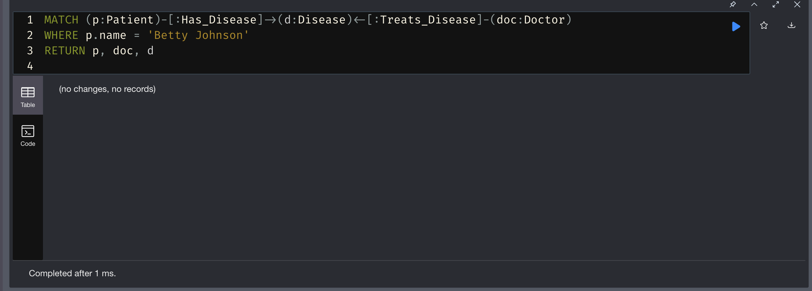

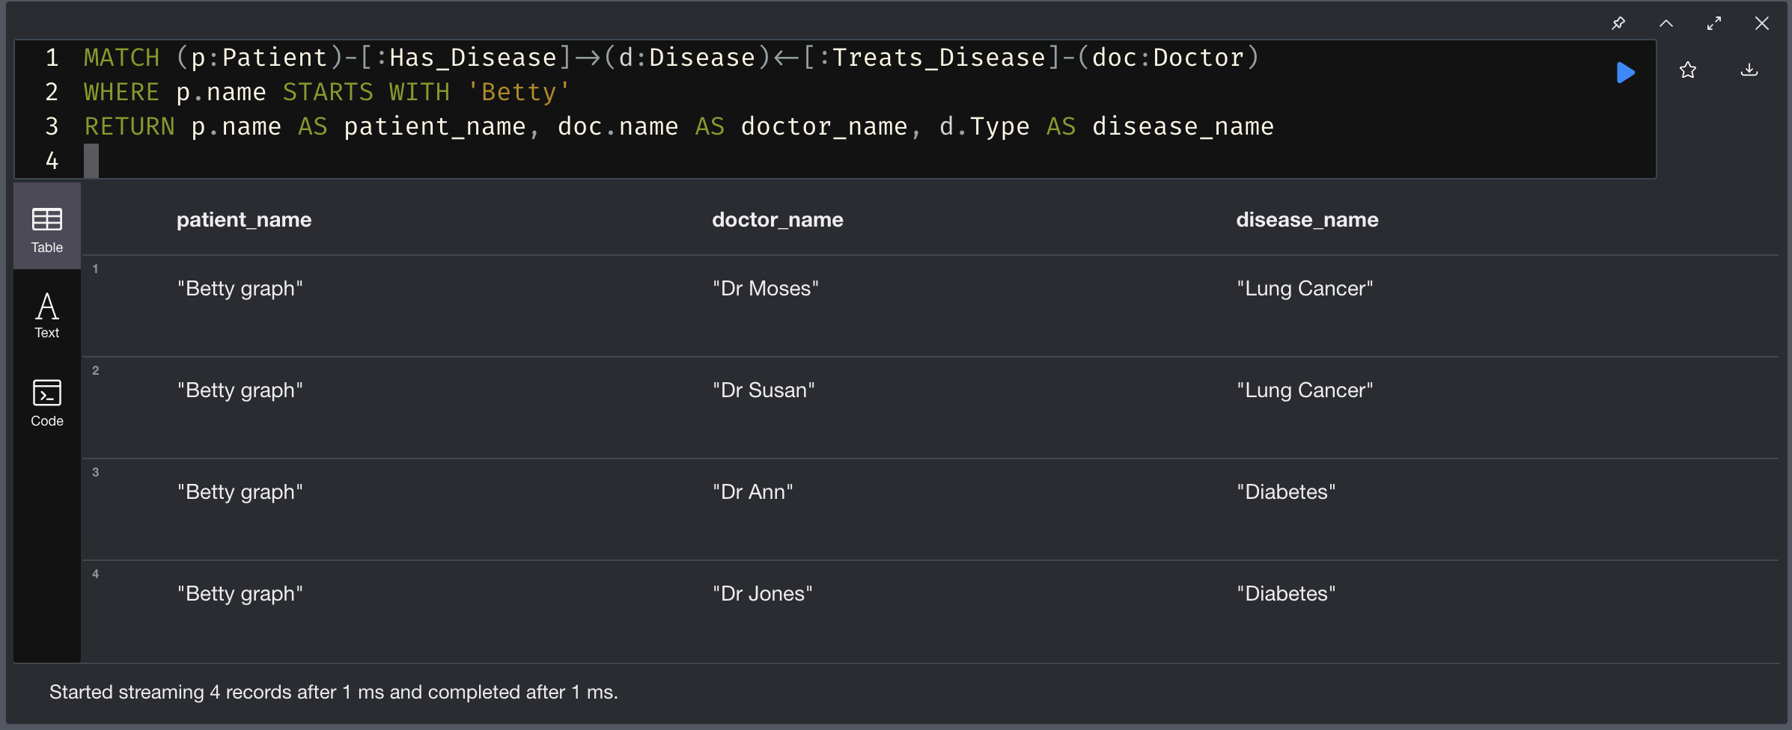

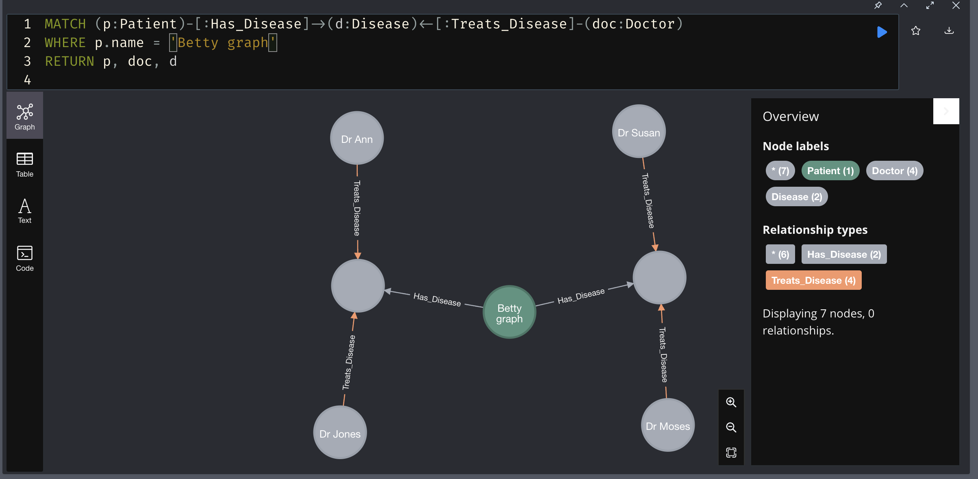

Question 4 – show me all the patients who have a female doctor

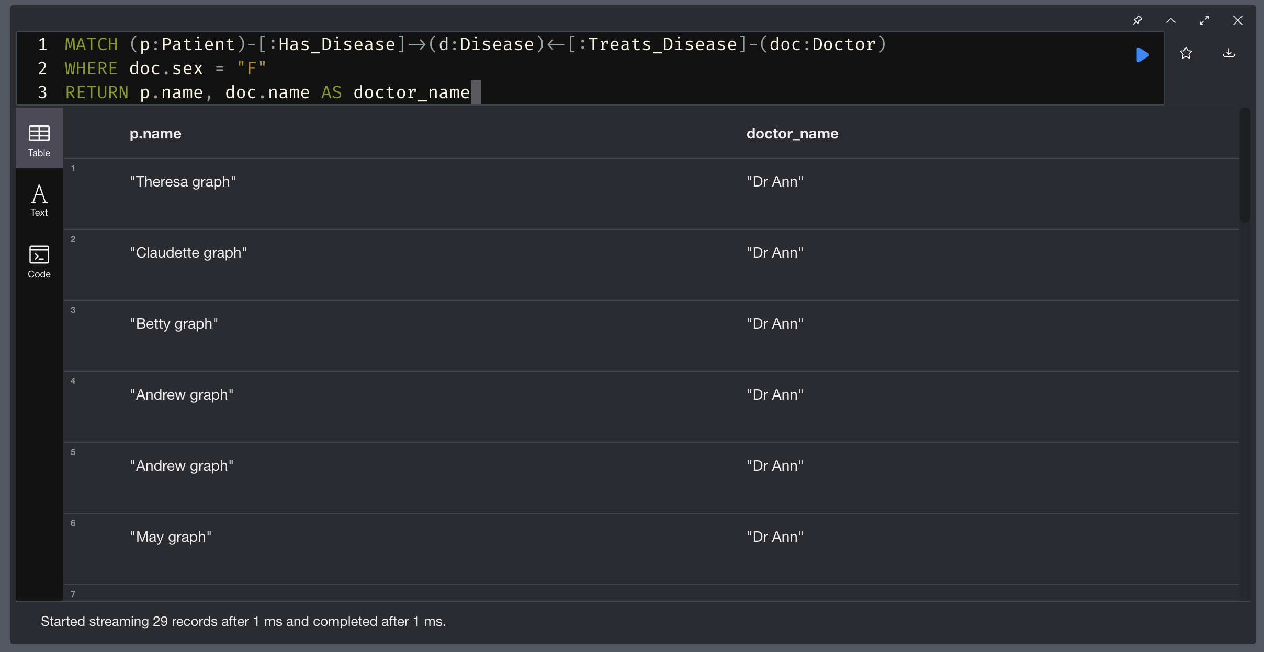

Question 5 show me all the patients who has a female doctor and that has any form of cancer



